The new Masteknet portal has gone live.  In this regard, please note the following:

1.       The URL to access the portal will be [www.masteknet.com](http://www.masteknet.com)

2.       The new SharePoint online portal is supported on multiple browsers and the supported versions are given below:

* Internet Explorer Ver. 9 and above (Please upgrade your browser if you are using prior version)
* Safari
* Chrome

3.         In order to access the new Masteknet, add the following URLs in the “Trusted Sites” under Tools >Internet Options > Security

1.         <https://ess.masteknet.com>

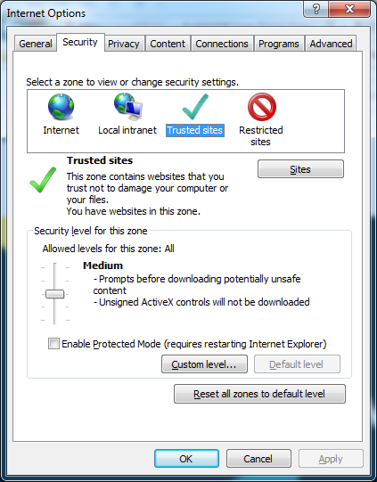2.         <https://mastekgroup.sharepoint.com>

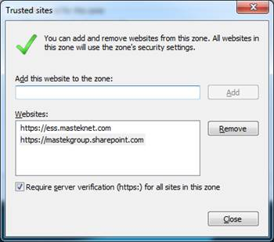

4.       If you are accessing Masteknet from Mastek network (India), you will need to make the following changes in the proxy server settings:

* 1. In Internet Explorer, click on Tools > Internet Options > Connections
  2. Click on button – "LAN Settings"
  3. Under the section on Proxy Server, click on Advanced button
  4. In the Exceptions list, write *mastek.com*; *office*; *lync*; *ess.masteknet*; *172.16*; *mastekgroup*
  5. Click on OK and exit the menu

After you are done with the above changes, please access the Masteknet URL ([www.Masteknet.com](http://www.Masteknet.com)).

Enter your credentials (<<[userid>>@mastek.com](mailto:userid@mastek.com)) on the login screen (1st screen) and click “tab” key. The browser will take you to the 2nd screen where you need to enter your password and then sign in to access Masteknet portal.

